 | LINKS ROAD SURGERY  27/29 LINKS ROAD  PORTSLADE ∙ BN41 1XH  Telephone: (01273) 412585  www.linksroadsurgery.co.uk
IMPORTANT INFORMATION FOR NEW PATIENTS

1. You MUST supply us with your NHS number which can be obtained from your current/previous GP surgery.

2. You must also bring two forms of identification in person when returning your completed forms, one from each category:

Photographic:
Passport
Driving license
Bus Pass etc.

Proof of address (dated within last 3 months):
Utility bill
Bank statement
Tenancy agreement

Please bring forms in
Any day between 9:30am and 5pm
(the surgery is closed between 1pm and 2pm)
-------------------------------------------------------

You will be given a practice leaflet which includes information on:

Our Reciprocal Practice/Patient Charter
Our “Zero Tolerance” to violence or aggressive behaviour
Our Did Not Attend Appointment processes and policy

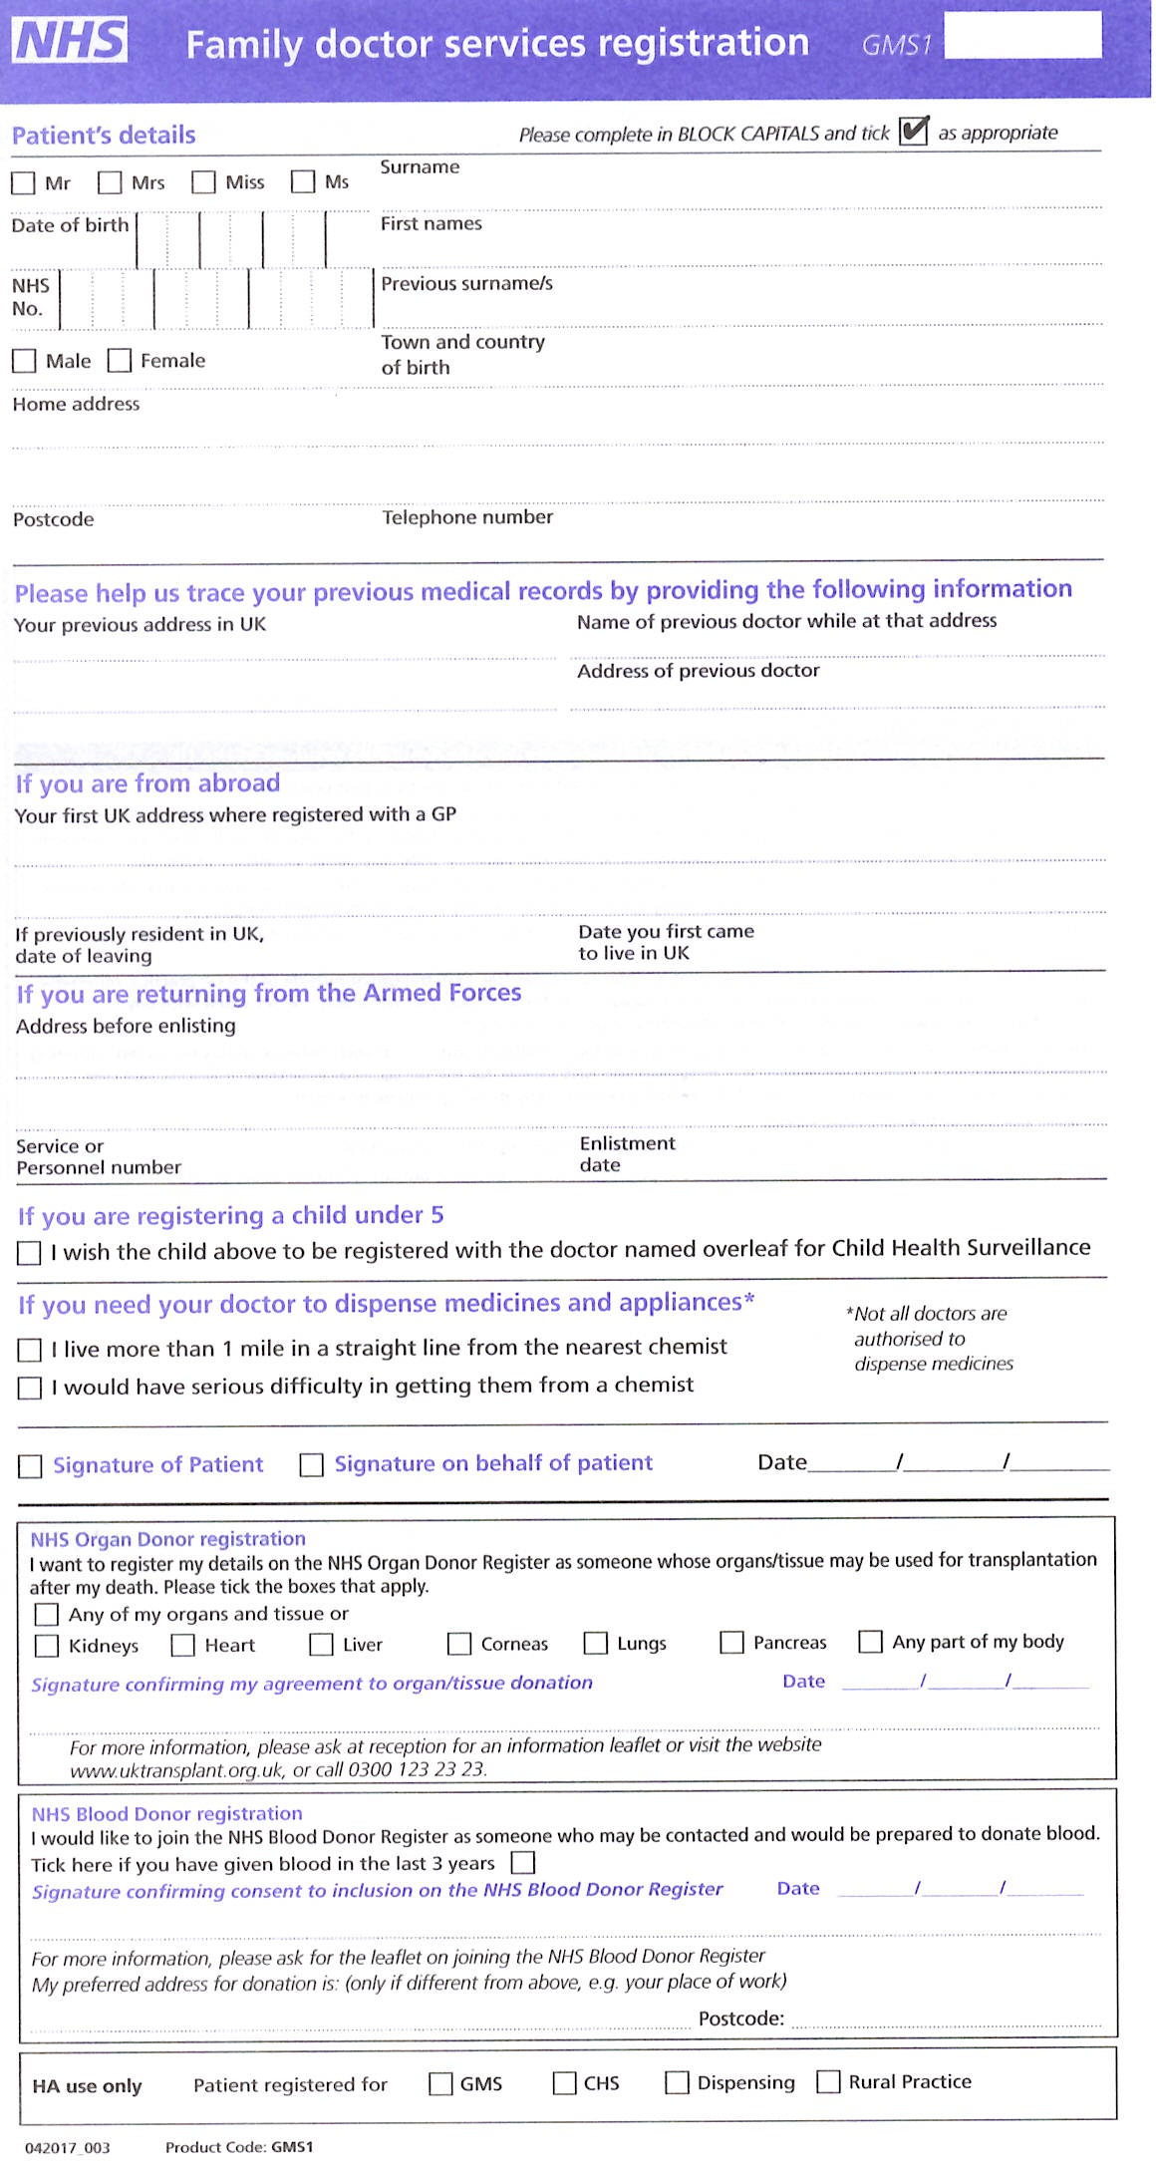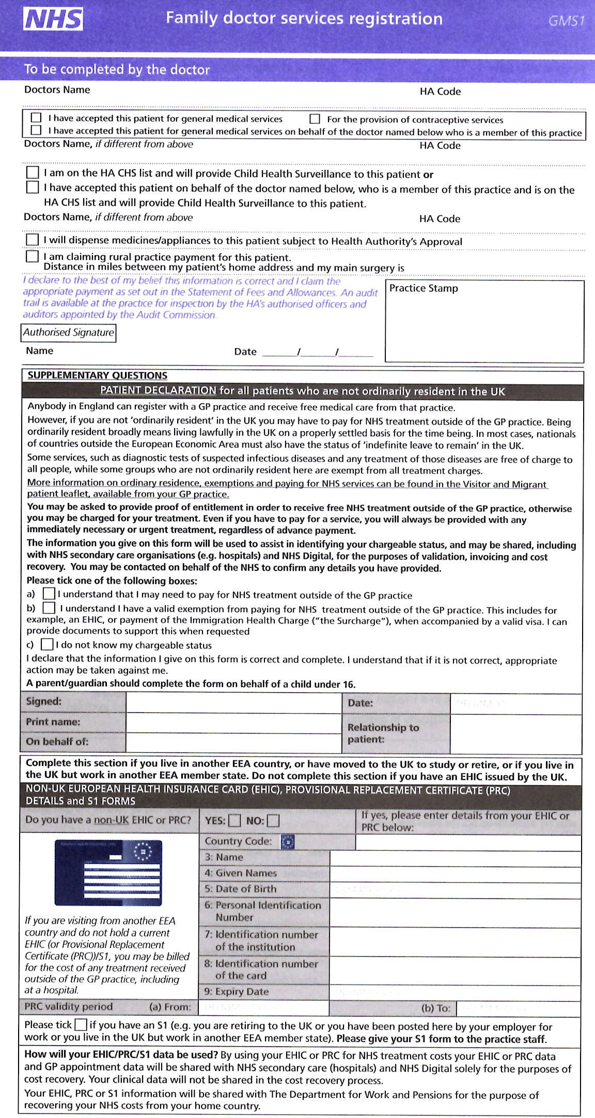
PLEASE FILL THIS FORM IN USING BLOCK CAPITALS

It is essential that you complete this form as fully as you can. It will help us ensure that you receive the best possible care

Name…………………………………………………………………

Date of Birth………………………….

Address…………………………………………………………………………………………………………………………………………………………………………………………………..
……………………………………………………………………………………………………..
Postcode ………………………

Home phone……………………………………………………………………………………..
Mobile phone…………………………………………………………………………………….
Work phone………………………………………………………………………………………
Email address……………………………………………………………………………………

Would you like to register for online services e.g. booking telephone appointments and ordering repeat medication? Yes No

In order to comply with our legal requirements of providing you with direct care we may need to contact you from time to time to discuss your health care, appointments, test results etc. This would include leaving a message on your answer phone.

From time to time we would like to contact you via SMS (text) to keep you informed of changes to the practice or to ask for feedback on how you think we are doing as a surgery. If you do not wish to be contacted in this way please advise one of our reception staff and they will record this on your records.
1
Do we have permission to keep you informed of changes to the practice or to ask you about how we are doing as a surgery via SMS (text)?
Yes No

If you said yes which telephone number is the best number to contact you on? _________________________________

Do we have permission to email you?
Yes No
Family History

Does your family have a history of any of the following? (Tick the correct boxes)

Angina
Asthma | High Cholesterol | Rheumatoid arthritis
Cancer | Hypertension | Schizophrenia
COPD | Ischaemic heart disease | Stroke
Coronary heart disease | Kidney disease | TIA/mini-stroke
Diabetes | Learning difficulties | Thyroid disease
Depression
Epilepsy
Please give details

If you have answered yes to any of the above please give us details including the year of diagnosis.

Now please tell us about any health conditions your family have had that are not listed above.

Have you ever had any other major illnesses, operations or mental health problems?
Yes No

Please give details

Your Medical History

Do you have a history of any of the following? (Tick the correct boxes)

Angina
Asthma | High Cholesterol | Rheumatoid arthritis
Cancer | Hypertension | Schizophrenia
COPD | Ischaemic heart disease | Stroke
Coronary heart disease | Kidney disease | TIA/mini-stroke
Diabetes | Learning difficulties | Thyroid disease
Depression
Epilepsy
Please give details

If you have answered yes to any of the above please give us details including the year of
diagnosis.

Now please tell us about any health conditions you have had that are not listed above.

Have you ever had any other major illnesses, operations or mental health problems?
Yes No

Please give details

YOUR HEALTH

Height: | Weight:
Your smoking status:

Never smoked
Ex - smoker
Quit date……………….

Current smoker

Stopping smoking will benefit your health. If you wish to discuss giving up smoking book for a smoking cessation appointment at reception.
Do you use any recreational drugs? |  | Yes No
Your blood pressure Date of blood pressure

........../………. ……/…./………

Free health checks

Free NHS health check- If you are generally well, i.e. not suffering from a long term condition, and are between the ages of 40 and 74 and have not had a NHS health check in the last 5 years, please book in for one with one Health Care Assistant.
Please arrange this ONCE you are registered with the practice by contacting reception.

Sexual health check - we offer free sexual health checks for chlamydia/gonorrhoea/HIV as well as hepatitis/TB screening for ‘at risk’ groups – if you’d like a check please book an appointment with one of our nurses.

Medications

Please provide a FULL list of your current medications – ideally please attach your repeat prescribing slip form your last GP.

If you don’t have this write the names of all the medications you take below along with the dosage and how often.
I.e. Simvastatin 40mg tablets Twice daily

Allergies

Any drug allergies or adverse reactions?  Yes No | Please provide date and details of the reaction
Any food allergies?  Yes No | Please provide details

ALCOHOL - Please complete the following questionnaire
This is one unit of alcohol…
…and each of these is more than one unit

Questions | Scoring system |  |  |  |  | Your score
Questions | 0 | 1 | 2 | 3 | 4 | Your score
How often do you have a drink containing alcohol? | Never | Monthly  or less | 2 - 4 times per month | 2 - 3 times per week | 4+ times per week
How many units of alcohol do you drink on a typical day when you are drinking? | 1 -2 | 3 - 4 | 5 - 6 | 7 - 9 | 10+
How often have you had 6 or more units if female, or 8 or more if male, on a single occasion in the last year? | Never | Less than monthly | Monthly | Weekly | Daily or almost daily
TOTAL:

A score of less than 5 indicates lower risk drinking
Scores of 5+ requires the following 7 questions to be completed:
Questions | Scoring system |  |  |  |  | Your score
Questions | 0 | 1 | 2 | 3 | 4 | Your score
How often during the last year have you found that you were not able to stop drinking once you had started? | Never | Less than monthly | Monthly | Weekly | Daily or almost daily
How often during the last year have you failed to do what was normally expected from you because of your drinking? | Never | Less than monthly | Monthly | Weekly | Daily or almost daily
How often during the last year have you needed an alcoholic drink in the morning to get yourself going after a heavy drinking session? | Never | Less than monthly | Monthly | Weekly | Daily or almost daily
How often during the last year have you had a feeling of guilt or remorse after drinking? | Never | Less than monthly | Monthly | Weekly | Daily or almost daily
How often during the last year have you been unable to remember what happened the night before because you had been drinking? | Never | Less than monthly | Monthly | Weekly | Daily or almost daily
Have you or somebody else been injured as a result of your drinking? | No |  | Yes, but not in the last year |  | Yes, during the last year
Has a relative or friend, doctor or other health worker been concerned about your drinking or suggested that you cut down? | No |  | Yes, but not in the last year |  | Yes, during the last year
TOTAL:
If you have scored 8 or more on the this questionnaire current medical evidence suggests that your drinking MAY be harmful to your health. We would like to discuss this. Please let us know here if you do NOT wish to be contacted. I do not wish to be contacted

Are you a carer? (i.e. Do you look after someone informally, for example, an elderly relative or somebody with learning disabilities)  Yes No | Whom do you care for?  Relative  Friend  Neighbour  Partner
Is the person you care for registered at this practice?  Yes No  If no please specify where. | If you would like information about support for carers, please tick the box and one of our nurses will contact you.
Social
Social and personal information
Occupation:  Employed/self employed  Unemployed  Full time Parent  At school/ college  At university  Retired | Housing type:  House  Flat  Bungalow  Other
Do you live alone?  Yes No  Name of next of kin:  Relationship to next of kin:  Next of kin DOB:  Contact details of next of kin:  Is your next of kin registered at this surgery?  Yes No | Please list the full names of the occupants of your home and their relationships to you.
 | Name | Relationship
 | Any children under the age of 18? Name, DOB, Address:

Communicating with you

Do you have visual or hearing difficulties? Yes No
Please give details

Do you have any other difficulties communicating? Yes No
Please give details

Do you need the services of an interpreter? If so which language?
Yes No ____________________________________________

EQUALITIES:
We gather the following information so that we can provide the best care for you. If you do not wish to share this information you are under no obligation to do so.

Gender | Male Female Other
Do you now, or have you ever considered yourself transgender? | Yes No  I do not wish to disclose this information

Please state which best describes your sexual orientation
Lesbian  Gay/homosexual  Bisexual  Heterosexual/straight | Unsure  Other (please state) ……………………………………  I do not wish to disclose this

Please indicate your religion or belief
Agnostic  Atheism  Buddhism  Christianity  Hinduism | Islam  Jainism  Judaism  Pagan  Sikhism | Other  …………………………..  I have no particular faith/I do not wish to disclose this
ETHNIC BACKGROUND

Please complete this form so that we can have a record of your ethnic background which will be helpful in providing the best medical care for you.

Choose ONE section from A to E below and tick the appropriate box to indicate your ethnic group (adding written information if necessary).

A White
British
Irish
Any other White background (please write in)

B Mixed
White & Black Caribbean
White & Black African
White & Asian
Any other Mixed background (please write in)

C Asian or Asian British
Indian
Pakistani
Bangladeshi
Any other Asian background (please write in)

D Black or Black British
Caribbean
African
Any other Black background (please write in)

E Chinese or other ethnic group
Chinese
Any other (please write in)



NHS Electronic Prescription Service - a new way to get your medicines and appliances.

The Electronic Prescription Service (EPS) is an NHS service. It gives you the chance to change how your GP sends your prescription to the place you choose to get your medicines or appliances from.

What does this mean for you?
- If you collect your repeat prescriptions from your GP you will not have to visit your GP practice to pick up your paper prescription. Instead, your GP will send it electronically to the place you choose, saving you time.
- You will have more choice about where to get your medicines from because they can be collected from a pharmacy near to where you live, work or shop.
- You may not have to wait as long at the pharmacy as there will be time for your repeat prescriptions to be ready before you arrive.

Is this service right for you?
Yes, if you have a stable condition and you:
- don’t want to go to your GP practice every time to collect your repeat prescription; or
- collect your medicines from the same place most of the time or use a prescription collection service now.
It may not be if you:
- don’t get prescriptions very often; or
- pick up your medicines from different places.

How can you use EPS?
You need to choose a place for your GP practice to electronically send your prescription to. This is called nomination. You can choose:
- a pharmacy.
- a dispensing appliance contractor (if you use one).

Ask any pharmacy or dispensing appliance contractor that offers EPS, or your GP practice, to add your nomination for you. You don’t need a computer to do this.

Can I change my nomination or cancel it and get a paper prescription?
Yes you can. If you don’t want your prescription to be sent electronically tell your GP. If you want to change or cancel your nomination speak to any pharmacist or dispensing appliance contractor that offers EPS, or your GP practice. Tell them before your next prescription is due or your prescription may be sent to the wrong place.

Is EPS reliable, secure and confidential?
Yes. Your electronic prescription will be seen by the same people in GP practices, pharmacies and NHS prescription payment and fraud agencies that see your paper prescription now.

Sometimes dispensers may see that you have nominated another dispenser. For example, if you forget who you have nominated and ask them to check or, if you have nominated more than one dispenser.

For more information visit www.hscic.gov.uk/epspatients, your pharmacy or GP practice.

Electronic Prescription Service
Patient Nomination Request

Patient name ………………………………………………………………………………………………

Address ………………………………………………………………………………………………………

……………………………………………………………………………………………………………………

Telephone Number.....…………………………………………………………………………………

DOB ………………….………………………………………………………………………………………..

NHS Number ………………………………………………………………………………………………
I am the patient named above/carer of the patient named above. Nomination has been explained to me and I have also been offered a leaflet that explains nomination.
Name and address of nominated dispenser:
Patient Signature……………………………………………………………………………………………………

Date………………………………………………………………….…………………………….


Information about your Summary Care Record

Dear patient,

If you are registered with a GP practice in England, you will already have a Summary Care Record (SCR), unless you have previously chosen not to have one. It will contain key information about the medicines you are taking, allergies you suffer from and any adverse reactions to medicines you have had in the past.

Information about your healthcare may not be routinely shared across different healthcare organisations and systems. You may need to be treated by health and care professionals who do not know your medical history. Essential details about your healthcare can be difficult to remember, particularly when you are unwell or have complex care needs.

Having a Summary Care Record can help by providing healthcare staff treating you with vital information from your health record. This will help the staff involved in your care make better and safer decisions about how best to treat you.

You have a choice

You have the choice of what information you would like to share and with whom. Authorised healthcare staff can only view your SCR with your permission. The information shared will solely be used for the benefit of your care.

Your options are outlined below; please indicate your choice on the form overleaf.

Express consent for medication, allergies and adverse reactions only.
You wish to share information about medication, allergies for adverse reactions only.

Express consent for medication, allergies, adverse reactions and additional information. You wish to share information about medication, allergies for adverse reactions and further medical information that includes: your illnesses and health problems, operations and vaccinations you have had in the past, how you would like to be treated (such as where you would prefer to receive care), what support you might need and who should be contacted
for more information about you.

Express dissent for Summary Care Record (opt out). Select this option, if you DO NOT want any information shared with other healthcare professionals involved in your care.

If you chose not to complete this consent form, a core Summary Care Record (SCR) will be created for you, which will contain only medications, allergies and adverse reactions.

Once you have completed the consent form, please return it to your GP practice. You are free to change your decision at any time by informing your GP practice.

Summary Care Record patient consent form

Having read the above information regarding your choices, please choose one of the options below and return the completed form to your GP practice:

Yes – I would like a Summary Care Record
□ Express consent for medication, allergies and adverse reactions only.
or
□ Express consent for medication, allergies, adverse reactions and additional information.

No – I would not like a Summary Care Record
□ Express dissent for Summary Care Record (opt out).

Name of patient: ………………………………………………..….........................

Date of birth: …………………………… Patient’s postcode: …………………

Surgery name: …………………………… Surgery location (Town): ……….................. NHS number (if known): …………………………..………………................................... Signature: ……………………………. Date: ………………………………
If you are filling out this form on behalf of another person, please ensure that you fill out their details above; you sign the form above and provide your details below:

Name: ………….........................................................................................................

Please circle one:

Parent Legal Guardian Lasting power of attorney for health and welfare

For more information, please visit https://www.digital.nhs.uk/summary-care- records/patients, call NHS Digital on 0300 303 5678 or speak to your GP Practice.

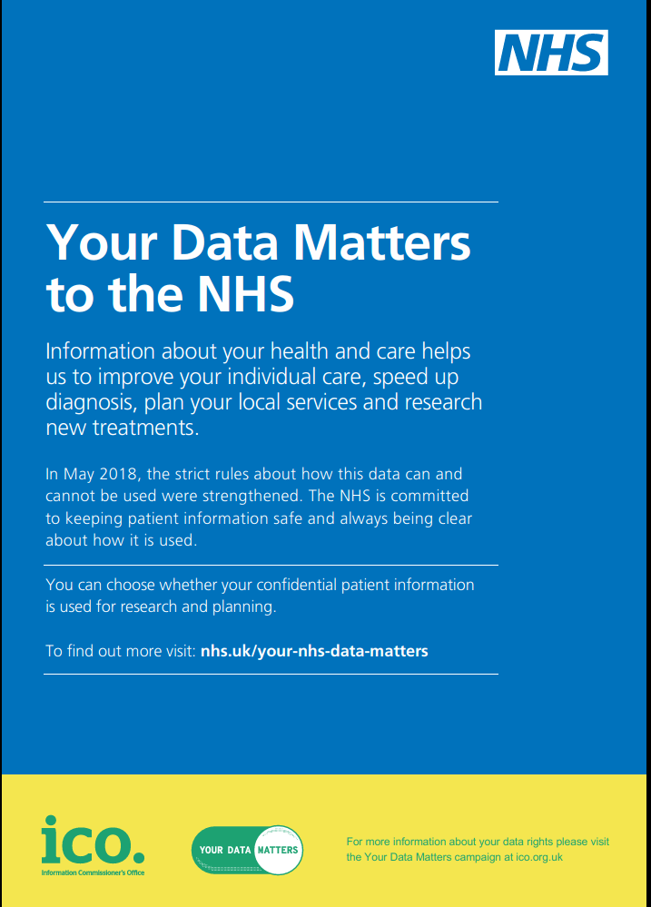

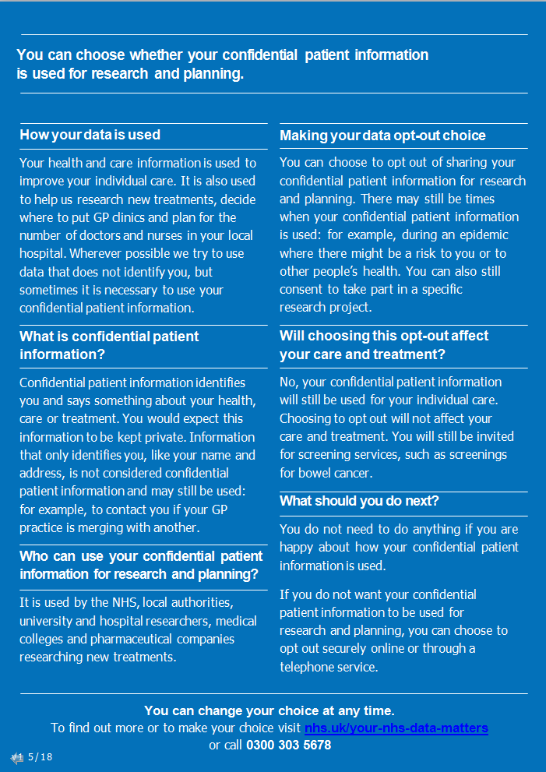
For Office Use only

I.D seen [ ]

Telephone numbers
SMS Consent ****
Email address
Online services
EPS Nomination

General clinical:

Smoking + leaflets given Declined
Weight
Height
Alcohol

Admin:

Allocated GP (XacWQ) Dr……..…………………….
If patient advised of GP when registering (Xab9D)
GP Access & rota
SCR Opt In Opt Out Recorded on notes
SCR IN/OUT explained

Summary Care Record:
(Brief explanation)
If you were to need urgent medical attention across the country the SCR is a national database accessible by NHS staff (only those who have the access rights) which holds limited data relating to your medical record: your NHS number, regular medication, recent acute medications and allergy history.
Checked by [ ]

Please read these important Practice Policies and statements.

In registering at this practice you will be accepting the terms and conditions as described below and agreeing to act in accordance with them.

Did Not Attend (DNA) Policy

These days, many patients complain that they cannot see a GP or Nurse quickly. Patients failing to attend appointments is a huge and avoidable waste of valuable GP and Nurse appointments. In the past 6 months over 90 hours of appointment time has been lost at Links Road due to patients who “did not attend”, this is equivalent to us losing a whole GP clinic every single week.
Please help us to avoid this by cancelling your appointment in good time (preferably 24 hours ahead) so that we may offer your appointment to another patient who needs it.

You can cancel your appointment in the following ways:
- online via our appointments app
- by replying CANCEL to your appointment reminder text
- by phoning 01273 412585 (you may leave a message overnight)
- by emailing us at contact.linksroadsurgery.co.uk

IMPORTANT INFORMATION WHEN YOU MISS YOUR APPOINTMENT
(OUR DNA POLICY)

- On all occasions you will receive a text communication (if you have a mobile/smart phone)
- The second time we will issue a “YELLOW CARD” letter to remind patients that in future they must cancel appointments if they are unable to attend.
- After three failures to attend we will issue a “RED CARD” letter and review whether or not to continue your care at this surgery (and we may consider advising you to register with another surgery).
To avoid all of this please ensure that you cancel your appointment in good time (and an absolute minimum of an hour before the appointment time. Anything cancelled after this time could still count as a DNA).

GP or Nurse Running Late?

Patients are usually allocated a 10 minute appointment but this may overrun if a patient is acutely unwell. Please bear with your GP/Nurse if they are running late. Another common reason for this is when patients themselves turn up late. If you are running late please telephone to advise us so that we may manage the waiting list. If you arrive or anticipate arriving more than 10 minutes late you will not normally be seen unless you are acutely unwell. If you are seen you may have to wait behind those already waiting, i.e. “out of turn”, patients are never seen on a first come first served basis. All of this ensures that we can do our best to keep our doctors and nurses on time.

Reciprocal Charter

- We offer a wide range of services and will always treat you with respect.
- You have a right to receive medical care from a suitably qualified medical practitioner. This will usually be by appointment with your allocated or preferred doctor but may be with another Doctor or an alternative and appropriate professional such as a Nurse or Health Care Assistant.
- We try to make sure that everyone is seen within reasonable period and try to keep all appointments to time, but apologise if we occasionally run late.
- You may request to be seen by a doctor of a specific gender or to have a chaperone pre- sent for intimate examinations although, on occasion, this may be by further appointment.
- You have the right to refuse to be examined in the presence of a student.
- Attending an appointment implies consent for examination or treatment. You may refuse this but a doctor may give essential treatment if a patient is considered to be incapable of understanding or giving consent.
- You may be seen at home if you are unable to attend surgery for a particular reason. You may be asked about your circumstances and the doctor may decide that you should attend
the surgery instead.

Please help us to help you!
- Please arrive on time and do not ask for urgent appointments for non-urgent problems
- Please cancel appointments in advance if the problem has cleared or you cannot attend.
- Please do not abuse telephone access to your doctor and keep telephone calls to the surgery to a minimum. Please do not telephone for test results or prescriptions.
- Please follow the advice or guidance that you are given by your health care professional.
- Please be considerate to the needs and feelings of other patients at the surgery.
- Please treat all staff with respect and refrain from the use of abusive language or threatening behaviour. Violence or Abuse will not be tolerated and patients will be removed from the list if they behave in this way.
- Complaints. We value suggestions and comments. Please see the Complaints Procedure section on this page for details.
- Further information on patients rights and responsibilities can be found in the NHS Constitution which is available online at www.nhs.uk/constitution.

Zero Tolerance to Violence Policy

All practices, in line with government guidelines, have a 'Zero Tolerance to Violence' policy.

This means that any violent or abusive behaviour or perceived threatening behaviour, whether verbal abuse, foul language or otherwise to staff or members of the public on practice premises will not be tolerated.

We can refuse to provide a service, report the incident to the Police and request that the patient and their family be removed from their Practice list.

