Links Road Surgery
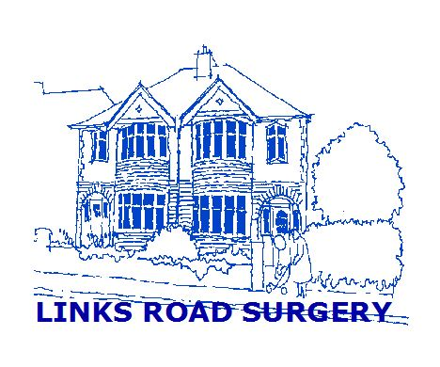

27 / 29 Links Road

Portslade

East Sussex BN41 1XH

Telephone Number: 01273 412585
L www.linksroadsurgery.co.uk

Links Road Surgery – Future plans

This letter has been sent to;
- each household of those patients aged 70 or over
- selected patients who we assist with ongoing management for their illness
- to patients without mobile phone or other digital access

This open letter has also been published to our website and Facebook page, and shared to local community (Facebook) groups.

Dear Patient,

We are sure you are aware that, over the past few years, the pressure on general practices has been growing. Although we have three GPs, you may be aware that in recent years we have seen a reduction in the number of GP partners at the surgery, and now Dr Ebbage is the last remaining GP principal.

Even discounting the impact of Covid19, GP surgeries face major challenges but notwithstanding these challenges, we are proud of our practice and the personal care we have maintained over the years. We have always been touched by the positive feedback and support from our patients. However we recognise that, in order to preserve high quality general practice that is robust and sustainable for the future, with the patient at the centre of that care, we need to look at working differently to secure the future of the practice for you, our patients.

After many months of consideration and discussion, we have decided to share our working arrangements with Sussex Primary Care. This is an organisation that has been established by Sussex Community NHS Foundation Trust (the NHS organisation that provides local community services, such as community nursing).

These new working arrangements will help to support the practice in areas like finance, maintaining buildings and some administrative functions. They will also create a closer working relationship between our practice and other community-based services, like community nursing, to provide better care for you.

What this means for you, the surgery and our staff:

- The practice stays open in its existing premises
- We have agreed terms to purchase the freehold of Links Road Surgery; moving away from our short lease arrangement secures the practice and our service for the future
- All of the Links Road staff, the GPs, Nurses, Paramedics, Reception and Admin team carry on working, but become employees of Sussex Primary Care
- We will continue to provide services for you in the same way that we do now
- We will get help, advice and support from a larger NHS organisation to help us deal with the pressures that we, like all local surgeries, are facing; this will include additional staffing support to help us to maintain and improve our care

Essentially this is a change of ownership with “business as usual” so you will not notice any changes. All of our doctors, practice nurses and other staff will continue to be available to you; the name and identity of the practice will remain the same; your registration with the practice and your day–to-day contact with the practice will not be affected. You do not need to take any action because of this letter.

We think this is good news for our patients, our staff and the services that we provide. We feel very positive about this change and wish to reassures you that the practice will continue to stay open, providing services as it does now, and will have the strength to adapt and improve in the current challenging and changing NHS environment.

If you have any specific questions, then we would like to hear from you but the surgery is very busy so;

Please do not telephone the surgery for information

You can get in touch with us in the following ways:

- Write to us at the practice address (above), or;

- Email us via our Patient Group who are collating and forwarding contacts for us
  - at the following email address ; ppg.linksroad@nhs.net

We look forward to continuing providing care for you in this enhanced way.

Yours sincerely,
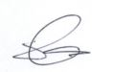
Steve Cribb
Practice Manager
Links Road Surgery

